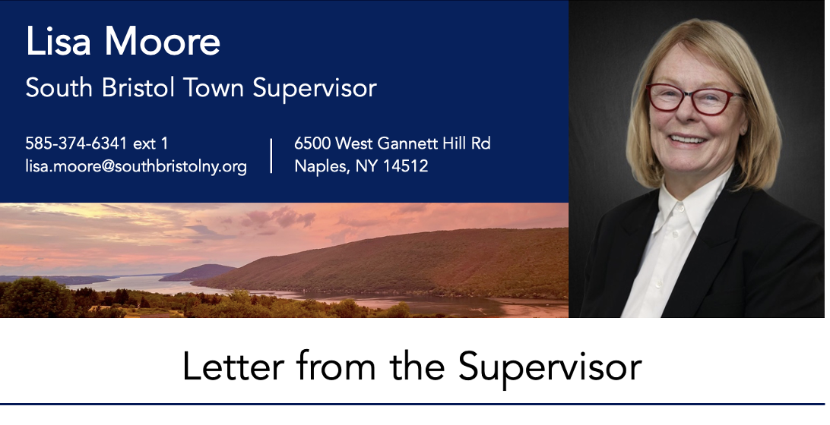
Hello fall foliage and all those who enjoy it!
The leaves are turning and there is a chill in the air. As we get ready for winter, town hall prepares our 2027 Budget. Many hours have gone into its preparation, and we are grateful for all the collaborations that have taken place with our department heads and for the input from our board members, friends at the county, especially Chief Financial Officer and South Bristol resident Mary Gates, NYS Comptroller’s office, committees, and others. Critically, there will be no tax increase for our residents in 2027. The 2027 budget allows for investments in two top priorities for which we wrote grants this past year—upgrading the Scenic Overlook, and the revision of our Comprehensive Plan—and builds in needed protections from an uncertain future in which inflationary pressures, and the ongoing potential for unbudgeted damage from the impacts of climate, present dangers to our town. Looking out to future needs, we have been able to craft a budget where we were able to make these changes by recognizing revenues and making prudent adjustments. This tentative budget will be presented at the town hall at a Budget Workshop on Saturday, October 10, at 8am.
On Monday, October 12, at 6pm there will be a Public Hearing at the South Bristol Town Hall on Banning Data Centers. A fixture in the national news, there are two major planned installations which are already causing communities in the Finger Lakes much concern—one on Seneca Lake and another on Cayuga Lake. South Bristol occupies over 20% of Canandaigua Lake’s shoreline, which is the third largest body of water in the Finger Lakes by volume. The state has issued a year-long moratorium on new data centers as it explores rising utility costs and the environmental impact that results from these resource-dependent facilities. What happens after the moratorium ends? At this Public Hearing, the Town Board wishes to hear from our residents on an amendment to the zoning law that would ban data centers in South Bristol. Please come and share your thoughts. We anticipate strong attendance, so please be courteous and mindful of the three minute limit for speakers taking privilege of the floor. Please target written statements to be around 400 words or fewer. Our usual Town Board Meeting follows directly afterward.
As protecting Canandaigua Lake and its watershed is a top priority for our town, we are very proud to report that our vernal ponds were installed at the Scenic Overlook this past week. These shallow basins catch and retain rainwater, enhancing natural habitat and creating seasonal pools that will help prevent harmful runoff and erosion. The project was funded by grant monies from the US Fish and Wildlife Service and obtained through close collaboration with our partners at the Finger Lakes Land Trust and the Soil and Water Conservation District. A result of our ongoing efforts to collaborate and develop mutually beneficial opportunities with these two organizations, the project came at no cost to the town, and is a major benefit for the lake.

Three vernal ponds were recently installed in Carolabarb Park, enhancing habitat & preventing runoff.
South Bristol is so grateful for our partners at the Finger Lakes Land Trust, the Soil and Water Conservation District, and the U.S. Fish and Wildlife Service, and the tireless dedication of their leadership who are constantly looking out for ways to protect this vulnerable watershed. Be sure to come to our next Community Conversation panel which will feature Megan Webster, director of Soil and Water Conservation, where we will be discussing other ways South Bristol can protect water quality in our region. It will take place at 7pm at Town Hall on Monday, October 26th. Emily DeBolt, Director of the Canandaigua Lake Watershed Association, Sam Seymour of AquaPoint, and Bruce Gilman, Professor Emeritus from FLCC will also be participating.
Finally, we wanted to recognize the dedication of the Ann Marie Rotter Memorial Bench that took place two weeks ago. The ceremony was conducted at the Community Playground on the Town Hall campus with a moving tribute from her daughter Haley. A longtime member of the South Bristol Town Planning Board and Bristol Hills Historical Society, Marie contributed to our community as a VA nurse, volunteer at Hospeace House, among many other volunteer efforts. Her spirit embodies the best of South Bristol.
With warmest regards,
Lisa
Lisa.moore@southbristolny.gov
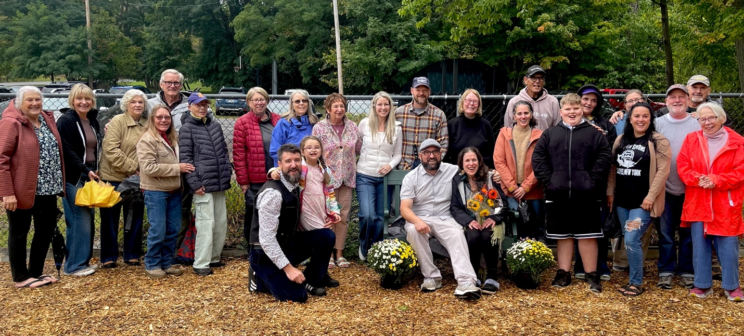
Residents commemorate the Marie Rotter Memorial Bench at the South Bristol Community Playground.

